Task Description:
Create a dockerfile, docker-compose file which when executed must display your basic details in the website.
Docker server created:
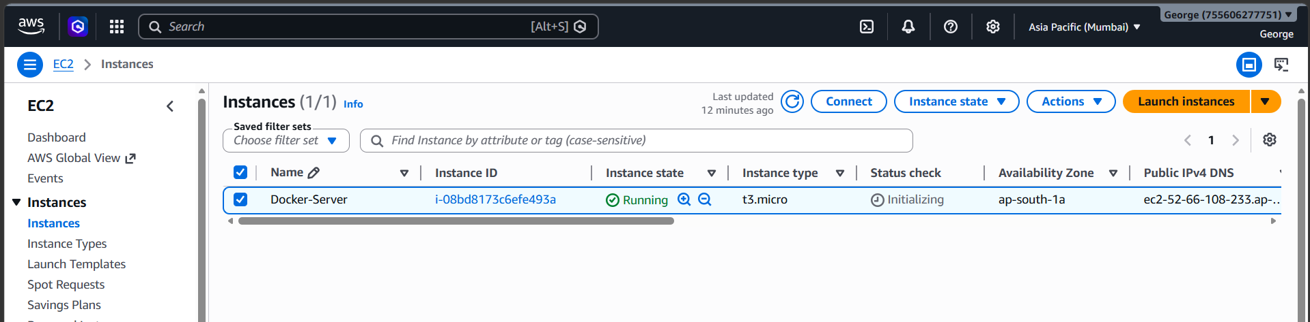
Docker installed on the server:
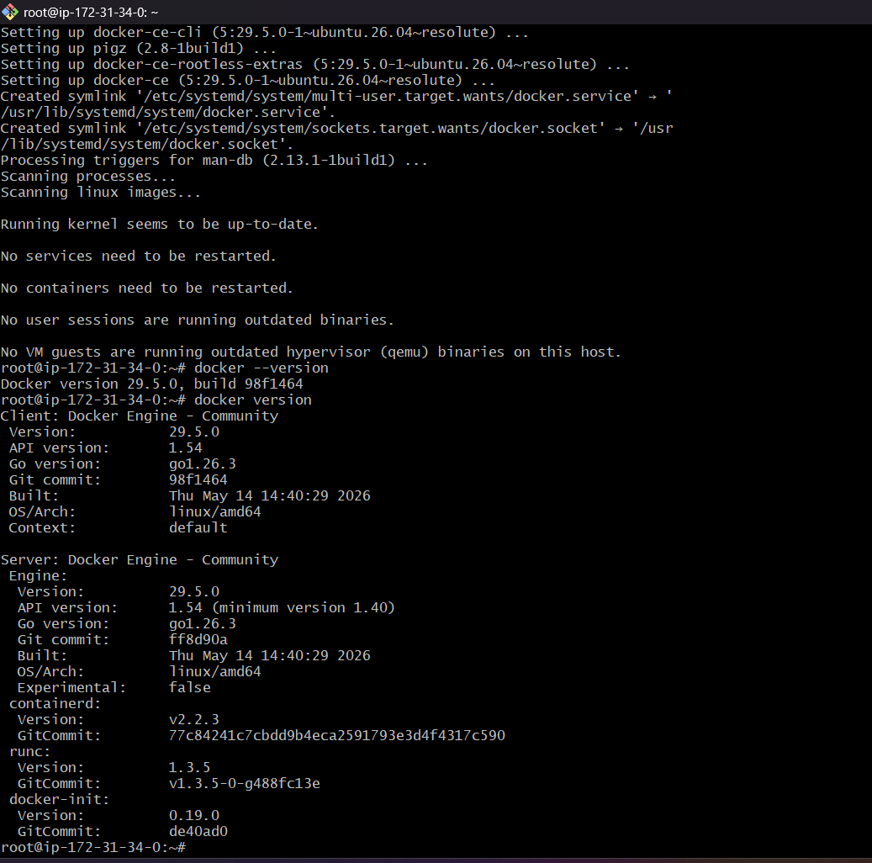
Clone the application code from github repository:
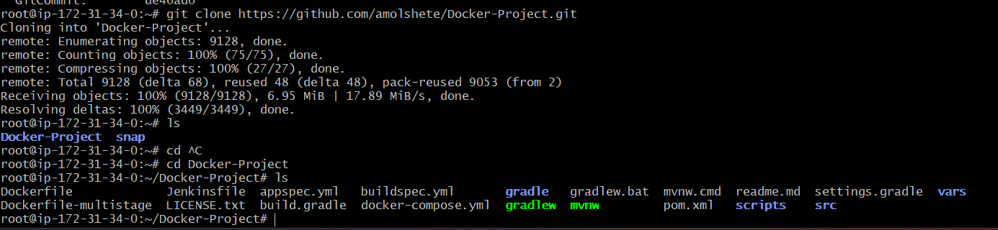
Maven installed on the server:
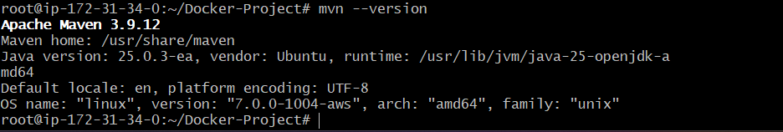
Maven builds successfully completed and jar files has been created:
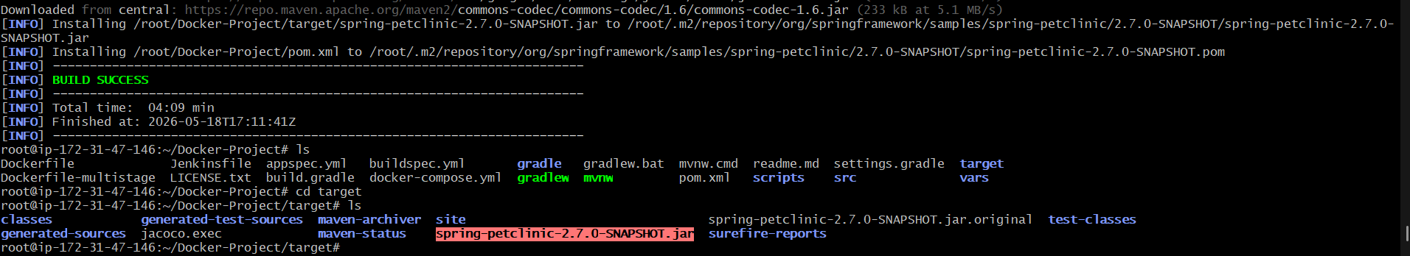
Docker file created:
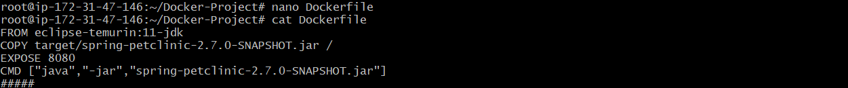
Build the image from artifact:
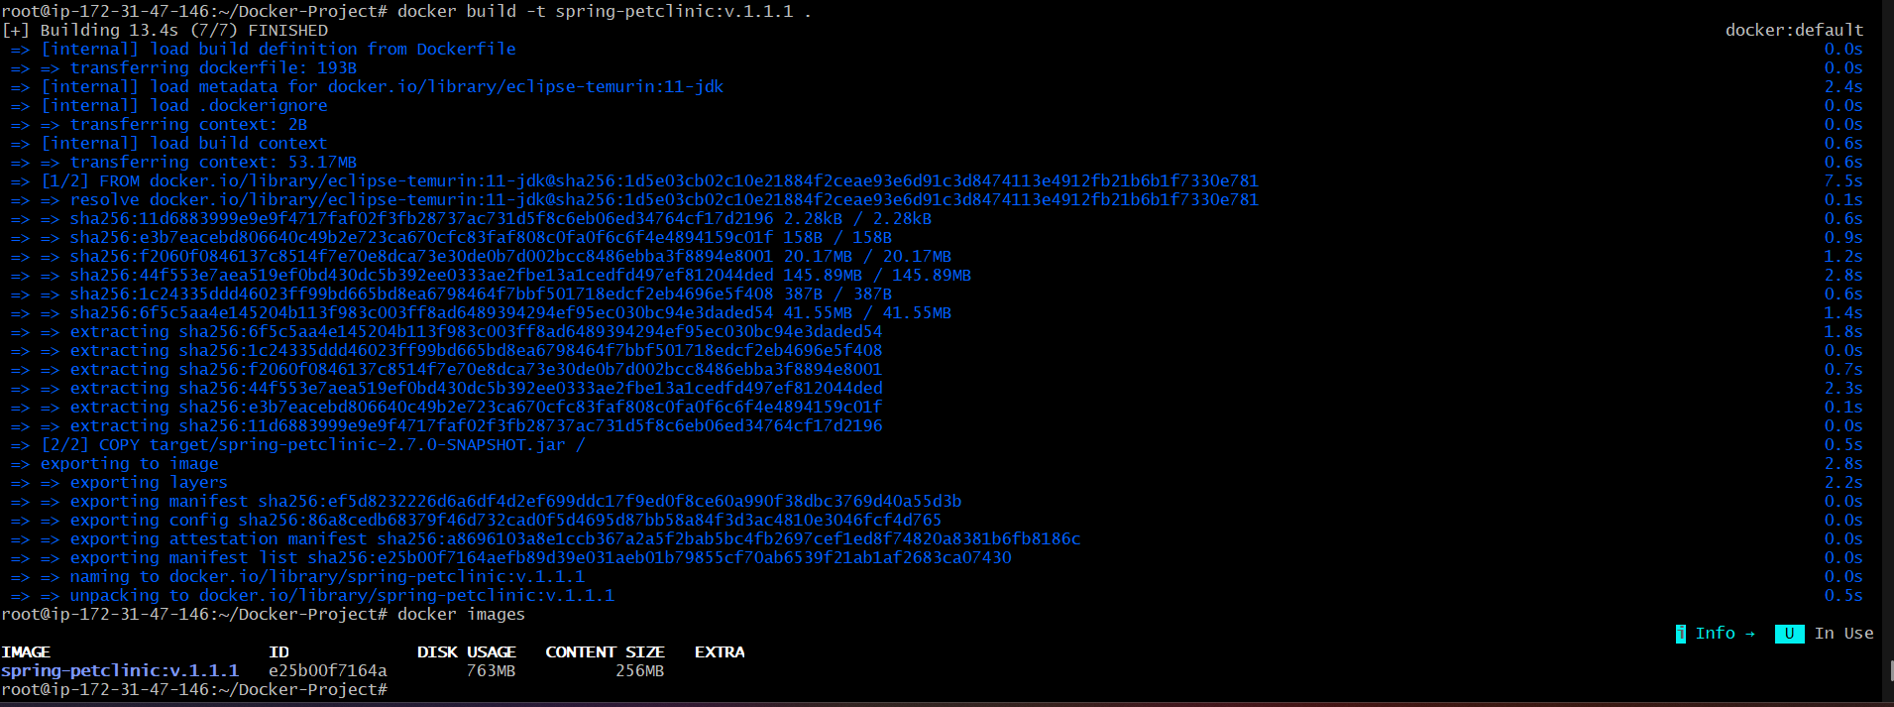

Pushing the docker image from server to docker hub repository:
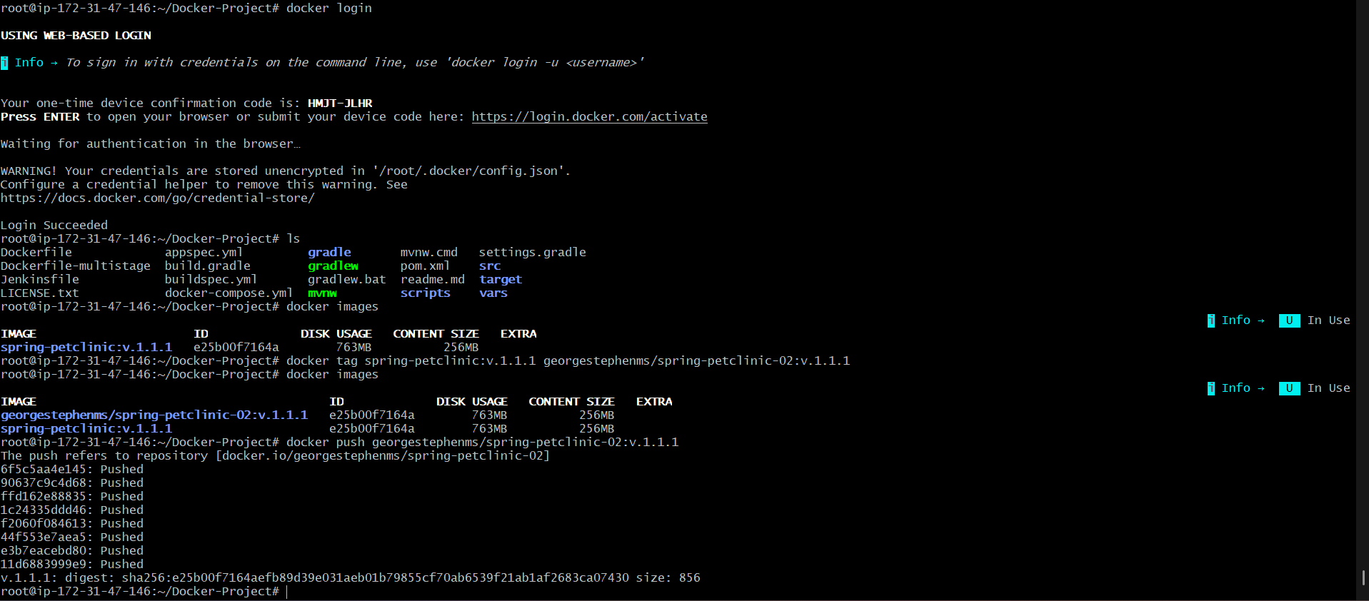
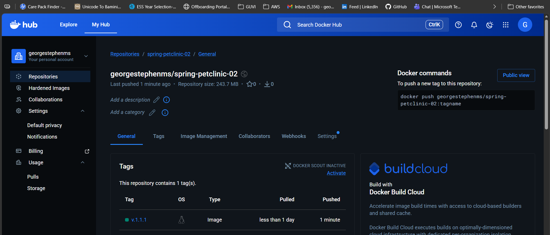
Container created:
Able to access the web page:
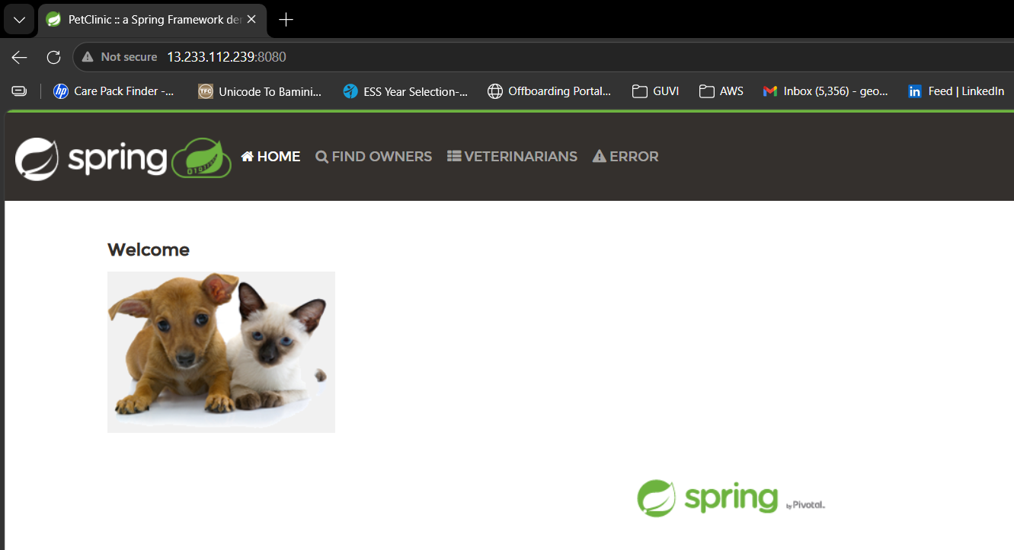
docker-compose file:
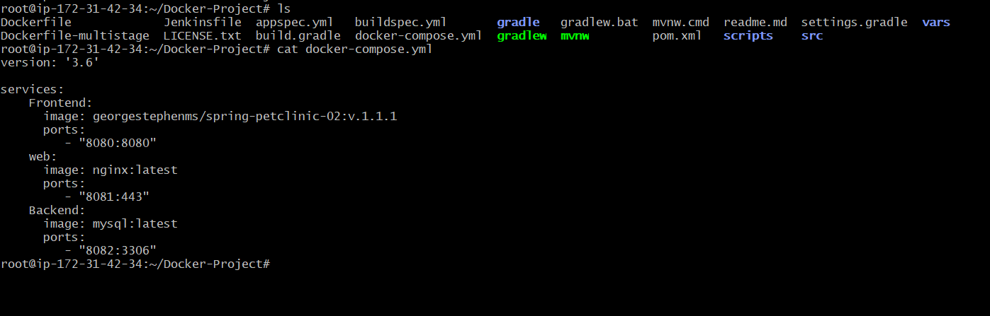
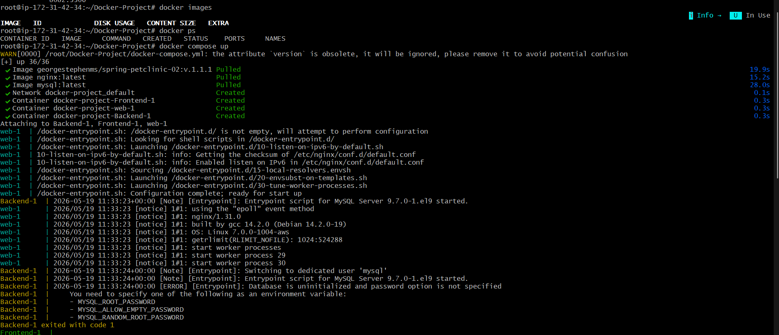
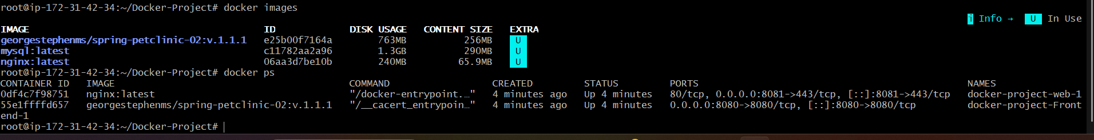
Able to access the web site:
